
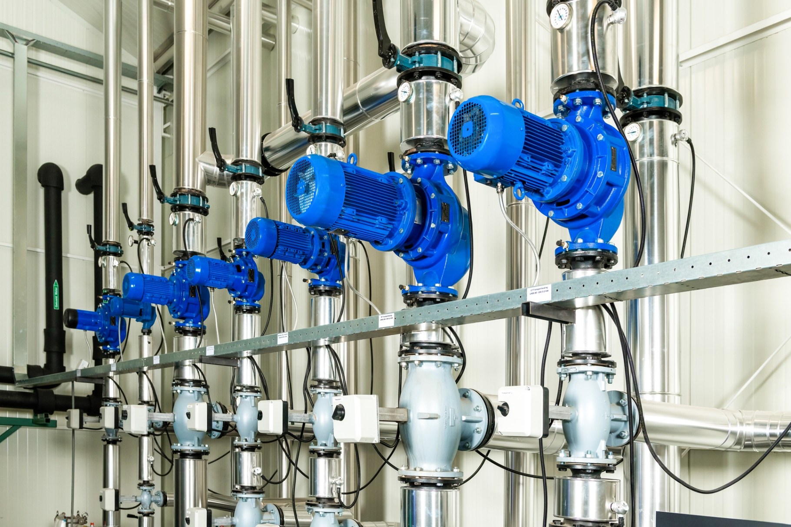



manual
The Curves selection tool developed by Van der Ende Group is an online tool that allows you to search for heating pumps. You can do this in two ways:

1. Search by required operating point
2. Search by name

The tool also allows you to save pumps in a project and request a price quotation for this project.

Contents

1. Register as a user 2
2. Overview of pump selection tool 3
3. Search by required operating point 4
4. Search by name 9
5. Projects 10
5.1 Create a new project 10
5.2 Overview of project page 11
5.3 Extra project fields 12
5.4 Submit project / request price quotation 13
5.5 Change a submitted project 14
5.6 Add pumps to an existing project 14
6. If you forget your password 16

1. Register as a user

You can register as a user by contacting the Sales office by email (sales@vanderendegroup.com) or telephone (+31 174 51 50 50). They will create an account for you.

To do this, they need the following information:

o Customer details
Name, address, post code, city, telephone number and general email address.
o Personal details
Last name, infix(es), first name, own telephone number and own email address.

The tool is designed to allow multiple users per customer. Users at the same customer can view and change all of each other’s projects.

After one of our colleagues has entered the information, we will send you an email with your login details. You will be able to use the details provided in this email to log in at https://curves.vanderendegroup.com/login and select your first pump.

2. Overview of pump selection tool

This chapter gives a brief overview of the various functionalities.
Log in at https://curves.vanderendegroup.com.

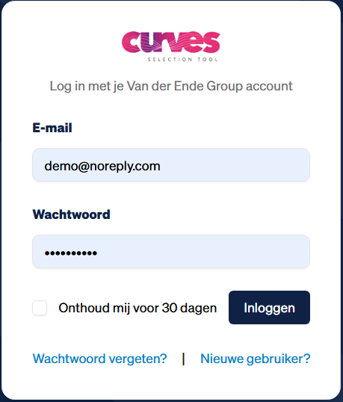
After you have logged in successfully, the following screen appears:
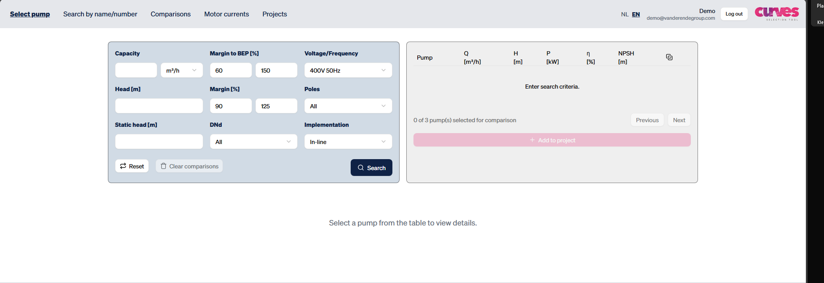

There are seven possible options:
1. Select pump Select a pump on the basis of a required operating point.
2. Search by name Search for a pump on the basis of part of the name.
3. Comparisons Here you can compare up to 3 pumps.
4. Motor currents Overview of motor currents in a PDF file
5. Projects Overview of created and submitted projects, and create a new project.
6. Change language Choose between NL or EN.
7. Log out To log out.

The user who is currently logged in is shown at the top, right of centre.

3. Search by required operating point

1. Log in at https://curves.vanderendegroup.com/login
2. Enter the required operating point.
o The capacity can be entered in either m³/h or ltr/min.
o The required discharge head and static head can only be entered in metres.
o The “Capacity” and “Discharge head” are required fields. The “Static head” is optional.
3. Click “Search”.
4. The tool displays the matching pumps for this operating point. The pumps are sorted by BEP
(best efficiency point).

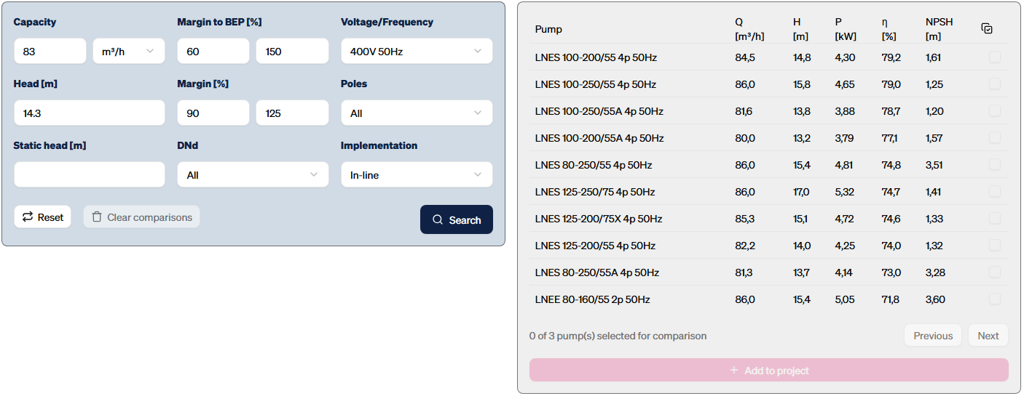
5. You have the option to filter the results:
o Margin compared with BEP (%) The default setting is “60 - 150”
This shows how far the required capacity may diverge from the capacity of the BEP.
More pumps will be shown if you choose a wider range between the lower and upper margin.

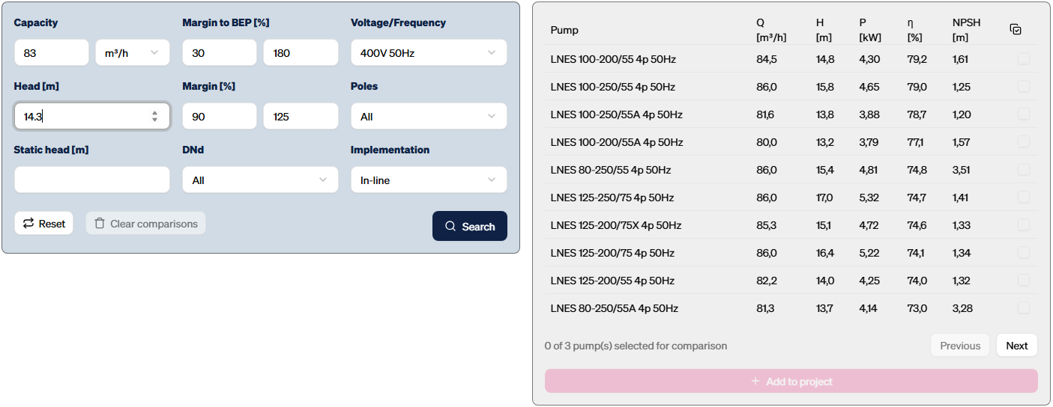

Fewer pumps will be shown if you choose a smaller range between the lower and upper margin.

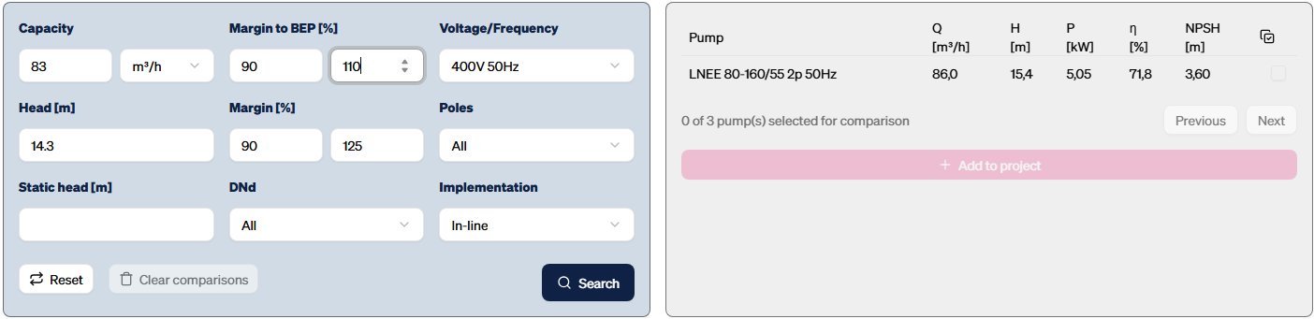

o Margin (%) The default setting is “90 - 125”
This shows how far the system curve’s intersection with the pump curve may lie above or below the required discharge head. More pumps will be shown if you choose a wider range between the lower and upper margin. Fewer pumps will be shown if you choose a smaller range between the lower and upper margin.

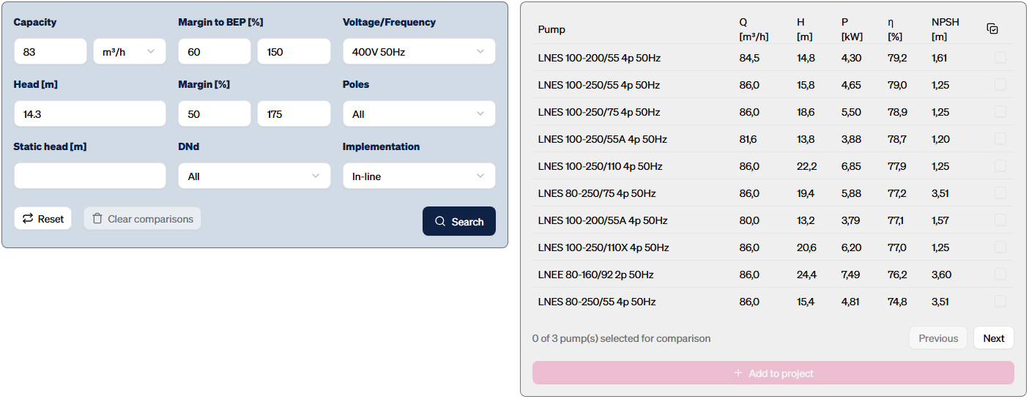

A margin starting at 100% will only show pumps that lie above the required discharge head.

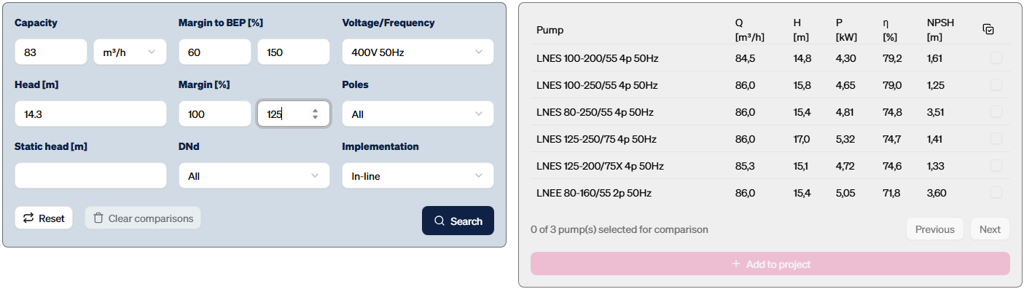
o Voltage/Frequency The default setting is “400V/50 Hz”.
You can search for 400V 50hz | xxxV 50Hz (if Voltage is different or unknown) | 400V 60Hz | 440-480V 60Hz | 575V 60Hz | xxxV 60Hz (if Voltage is different or unknown).

o Number of poles The default setting is “All”.
You can search for 2-pole, 4-pole or 6-pole or all pole pairs.

o Type The default setting is “Inline”.
You can search for in-line or block or both pump types.

o You can also filter by DNd size (= size in mm of the discharge connection)

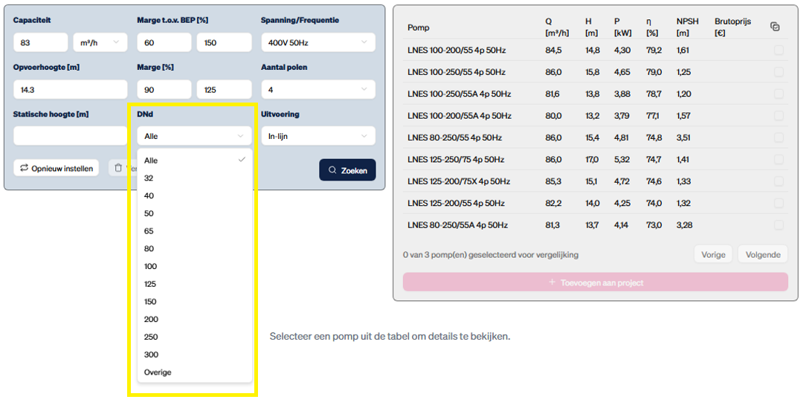
6. The curve and additional details of the pump can be viewed by clicking the pump name.
The power, efficiency and NPSH curves become visible when you scroll down. A different pump
can easily be viewed by clicking the pump name.

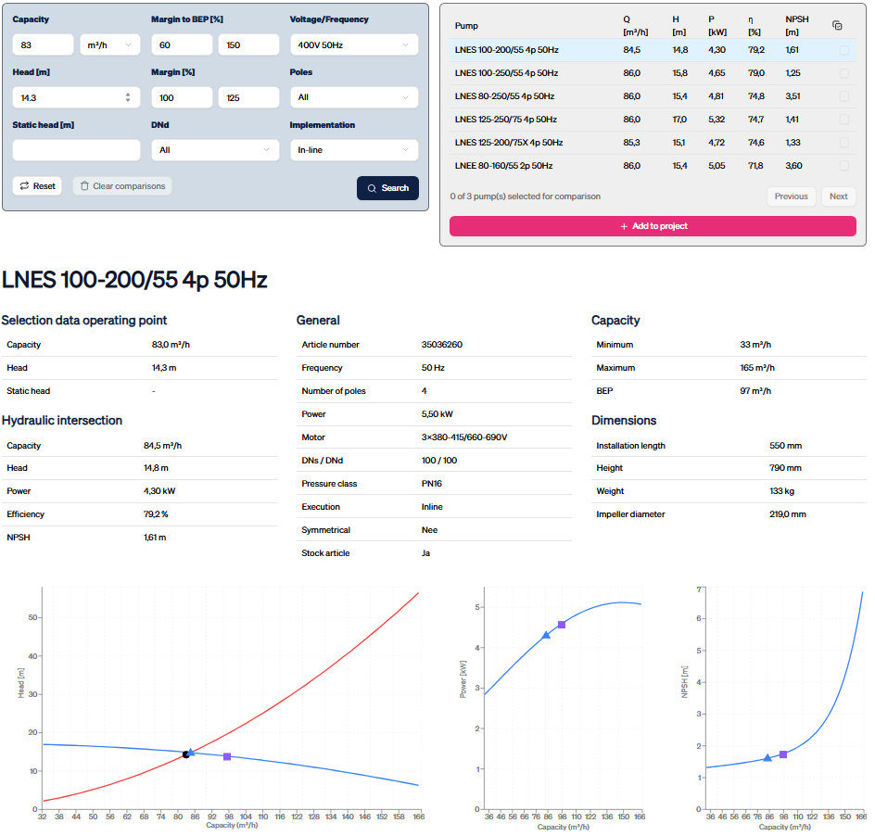

7. You can search for a pump for a different operating point by entering a new capacity and discharge
head.

8. The search function can be reset to the default settings by clicking “Reset”.

4. Search by name

1. Log in at https://curves.vanderendegroup.com/.
2. Click “Search by name/number”.

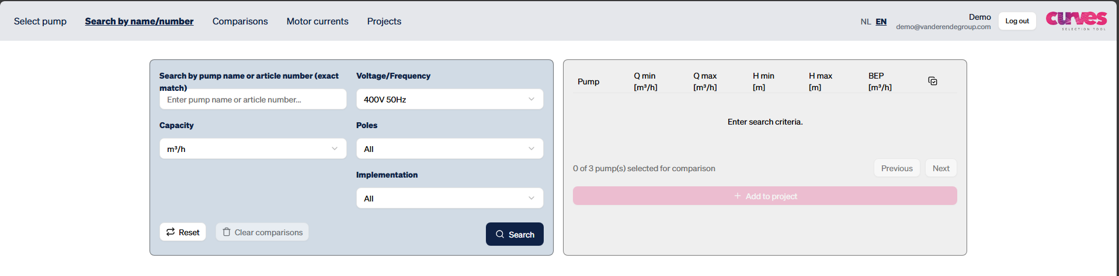

3. Enter part of the name and click “Search”. The order of the words is not important, but you should make sure that you enter a space between the words.

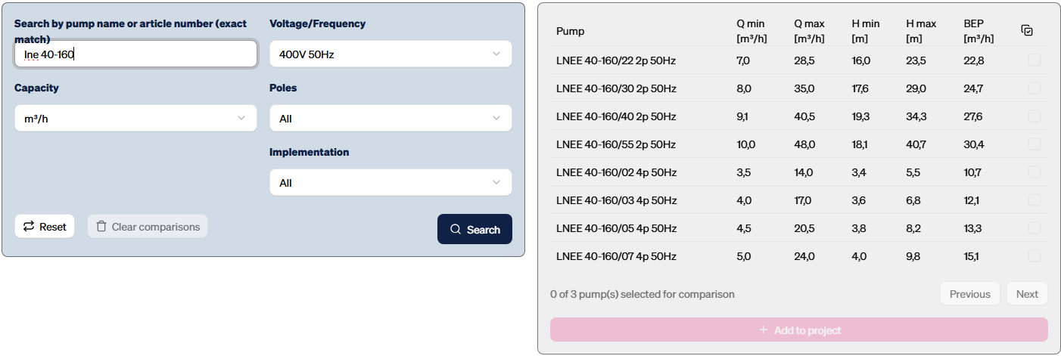

4. To filter the results, the procedure is the same as described at “Search by required operating point” (page 7).

5. Projects

In addition to searching for the pumps by required operating point or name, the pumps that are found can be added to a project. Projects can then be submitted in order to request a price quotation for the selected pumps. Via the project page, it is also possible to see which projects have been created, and to change these projects.

At first, you can only add pumps to the unsaved project. After multiple projects have been created, you can also add pumps to existing projects. The pumps that are added to an unsaved project, and are not saved under a unique name, will continue to be saved under the unsaved project after you log out.

5.1 Create a new project
It is also possible to start with a new project. To do this, you should first enter the project details and then add pumps to this project.

1. Go to the project page and click “New” at the top right.

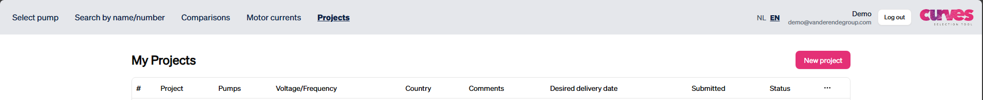

2. Enter the project details. When the project has been saved, you will be able to add a pump directly from “Select pump” by clicking “Add pump”.

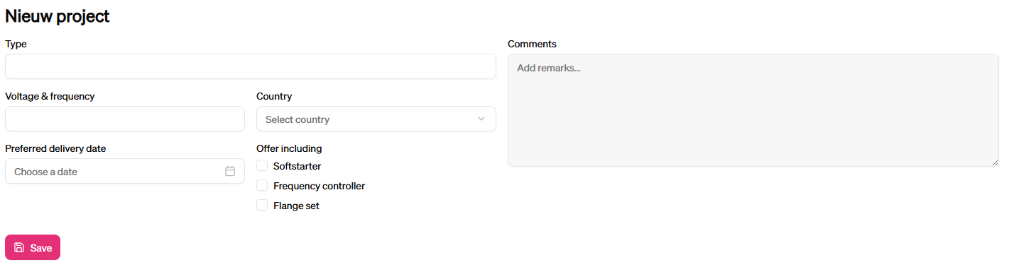

3. Search for a pump and add it. The name of the project will already be shown.

5.2 Overview of project page
The project page shows an overview of all projects. Under “Submitted” you can use the dropdown arrow to choose submitted, unsubmitted or all projects.

The text “There is an unsaved project. View or edit” is only visible if an unsaved project contains pumps.

If you hover the mouse above the “Remarks” field, the general remarks relating to this project will become visible.


to edit the project
Submitted here is shown is the project has been submitted or not
Status here is the status of the project shown; open, order or expired

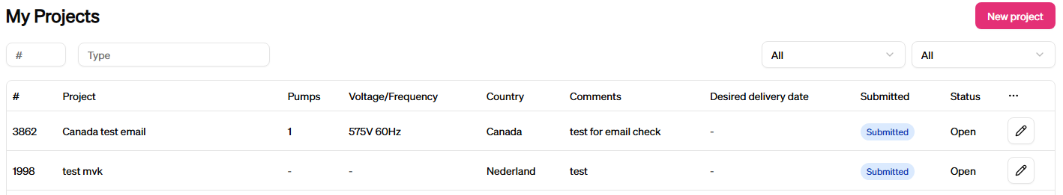

5.3 Extra project fields
When a project is opened via the project page, there are several options.

Project details
o Name Required.
o Voltage/Frequency Required.
o Country Optional, for control voltage and frequency, if applicable.
o Date Optional, for price quotation/delivery time.
o Remarks Optional, for additional remarks about the project
(will also be shown in a balloon in the project overview).

History
Shows who created and edited the project.

Pumps
•  Click and hold this icon to change the order of the pumps (drag and drop).

• Remarks Additional remarks about the pump, for example the intended application.
• Quantity The quantity of pumps can be changed here.
• Pump name Click the pump name to show the curve again.
Other
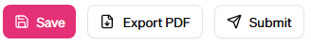
• Export Creates a PDF of the project.
• Add pump Shortcut to “Select pumps”.
• Submit Sends project details to Van der Ende Group, so that a price quotation can be produced.

5.4 Submit project / request price quotation
After you have added all the pumps required for a project, you can request a price quotation for this project. To do this, open the project on the project page and click “Submit”. You will then be asked whether you are sure: click “OK” or “Cancel”.

If you click “OK”, our Sales department will receive a message, and they will send you an email as soon as possible with a price quotation for the selected pumps.

5.5 Change a submitted project
You can still change a project that has already been submitted. Click “Revise” to create a new version in which you can make changes. The revised request can then be treated as a normal project
and re-submitted.
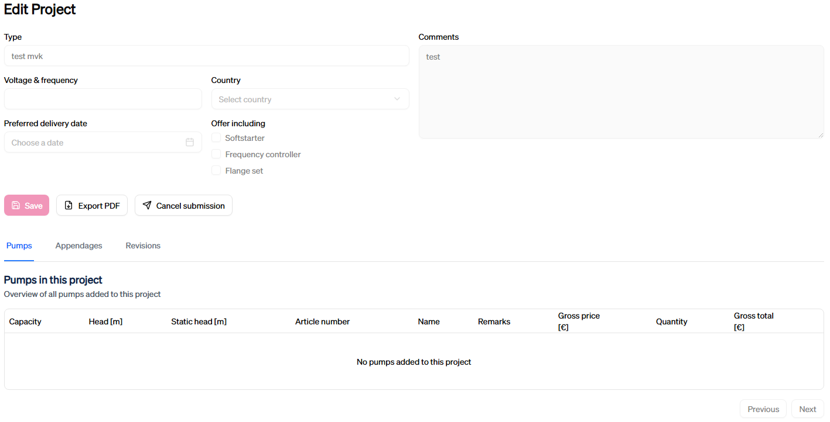

5.6 Add pumps to an existing project
1. Select a pump from the search results.

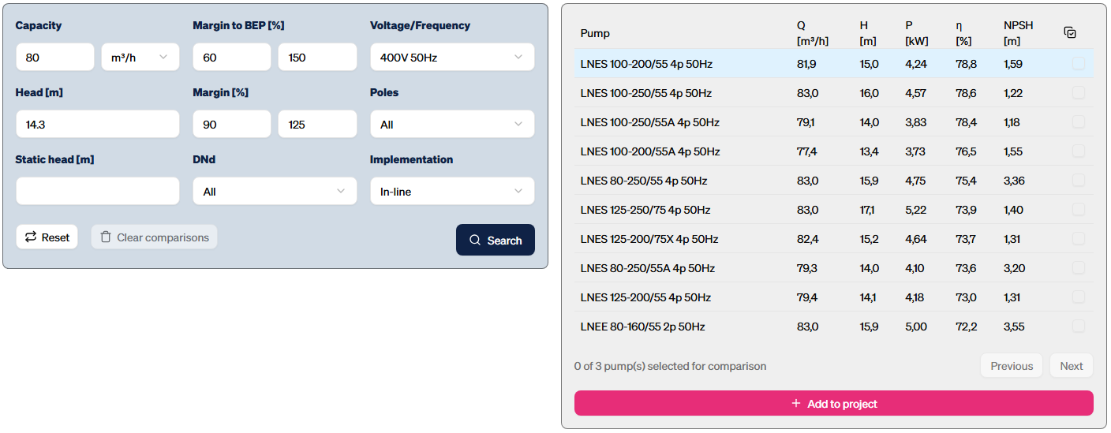
2. Click the dropdown arrow and select the required project.

3. Below, you can specify the number of pumps, add a comment, and select a specific project.

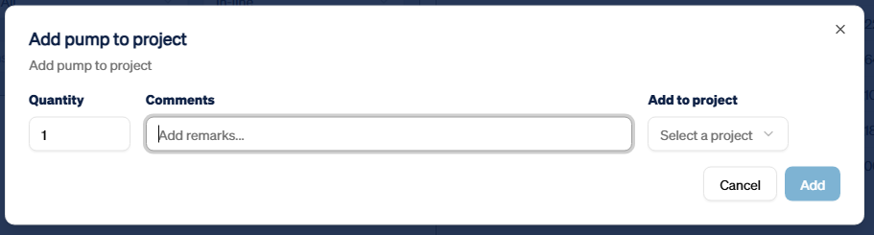

6. If you forget your password

If you forget the password that was sent to you by email, please call our Sales office
on +31 174 51 50 50.

