Application form airmix
Filled in by | ......
Date | …... - …... - …...

Installer
Company name | ……
Debtor number | ……
Contact person | ……
Phone number | ……
E-mail | ……
Installation location
Company name | ……
Contact person | ……
Address | ……
Postal code + City | ……
Phone number | ……
Email | ……
Country | ……
Greenhouse specifications
Add a greenhouse floor plan with the following included:
- Clear dimensions (free span and bay width included)
- Concrete pathway(s)
- Current installed fans (if present)
Rolling screens/ fixed walls (if present)
Height ground  to underside of truss | …… meter
Truss specifications | Please fill in appendix I
Screen installation | ☐ Single / ☐ Double / ☐ Triple screen  (tick as applicable)  Screen 1  Type of screen: …………………………………………………………..…..  Mounted on:  - ☐ Upper truss profile  - ☐ Lower truss profile  - ☐ Between truss profiles  Screen 2  Type of screen: …………………………………………………………..…..  Mounted on:  - ☐ Upper truss profile  - ☐ Lower truss profile  - ☐ Between truss profiles  Screen 3  Type of screen: …………………………………………………………..…..  Mounted on:  - ☐ Upper truss profile  - ☐ Lower truss profile  - ☐ Between truss profiles
Lighting | Type of lighting  - ☐ HPS (Son-T)  - ☐ LED  - ☐ None  Lighting capacity: …………….. lux or …………….. µmol/m²/s
Cultivation
Type of cultivation | ……
Cultivation height | …… cm
Desired ventilation capacity | …… m³/m²/h (see appendix II for more information)
Airmix
Airmix mounted on: | ☐ Upper truss profile  ☐ Lower truss profile
Control Airmix by | ☐ Temperature  ☐ Relative humidity / Absolute humidity  ☐ Cooling when shading (black-out)
Type of Airmix  (see appendix III for more information). | ☐ Airmix model T  ☐ Airmix model G
Options  (see appendix IV for more information) | ☐ Condensation collection plate  ☐ Speed controller (manual)  ☐ Speed controller M-0-A (Manual – Off – Auto)  ☐ Outlet grille  ☐ Air flow conductor …… piece(s) per fan  ☐ Mounting bracket for the air flow conductor
Electrical | ☐ 1x 230 Vac, 50 Hz  ☐ 1x 230 Vac, 60 Hz  ☐ 1x 200-240 V EC, 50-60 Hz  ☐ Other, i.e.: ……
Airmix valve position measuring device | …… piece(s) (one per Airmix controlled department, see appendix V for more information)
Cultivation growth advisor
Name | ……
Phone number | ……
Email | ……
Screen installer
Company name | ……
Contact person | ……
Other
Climate computer | Type of climate computer: …………………………………………………………..…..
Obstacles | Please fill in appendix VI

More information about the Airmix can be found on our website:
vanderendegroup.com/sectors/horticulture/horticultural-fans

Appendix

Appendix I – Drawing truss

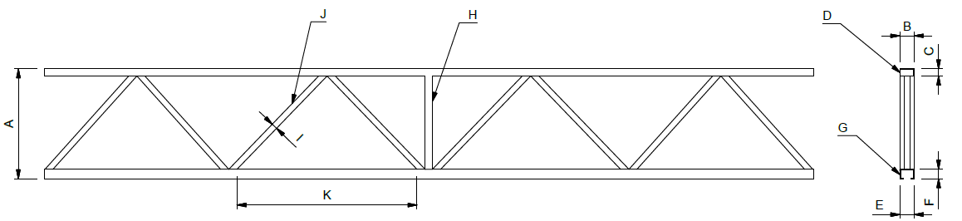

Truss height A: | ……………………………… |  |  | mm
Profile [B x C]: | ………… | x | ………… | mm (attention when B = > 70mm)

Appendix II – Ventilation capacity

The ventilation capacity required to dissipate sufficient moisture and / or heat depends on the amount of moisture the crop produces or the heat released by the lamps. This is very different per crop and cultivation method. If the desired amount of m³ per m² per hour is known, the amount of Airmix (ventilation) capacity to be installed is calculated. With rose cultivation, this means that a ventilation capacity of ± 20 m³ / m² / hour can be requested. In this situation, one Airmix is mounted one per 250 m².
A completely different example is an unlighted vegetable cultivation where a ventilation capacity of ± 5 m³ / m² / hour is required. In this situation, one Airmix is mounted one per 1000 m². This results in a low number of fans to create sufficient horizontal circulation. This is compensated for by installing horizontal fans between the Airmix systems.

Appendix III – Type of Airmix

Airmix model T
The Airmix model T consists of a fan, mounted on an aluminum housing which has two valves at the rear and is open at the top. The housing of the Airmix connects to the screen where a hole is made. These valves are adjustable by means of a valve position actuator. The Airmix has a connection cable with a plug for the fan (only 1x230V 50Hz version) and a connection cable for the valve position actuator.

For more information about hanging the Model T, see our manual via the link:
VDEG Airmix model T

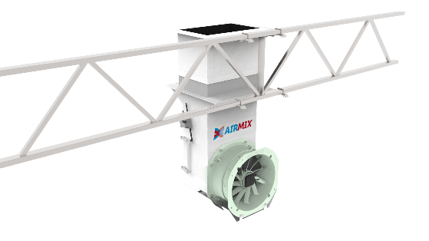
Airmix Model G
The Airmix model G consists of a fan, mounted on an aluminum housing which has three valves at the rear and is open at the top. The Airmix needs aluminum mounting profiles to be able to be attached to a truss. The valves are adjustable by means of a valve position actuator.
The Airmix has a connection cable with a plug for the fan (only the 1x230V 50Hz version) and a connection cable for the valve drive. The Airmix has no internal control.

For more information about hanging the Model G, see our manual via the link: VDEG Airmix model G.

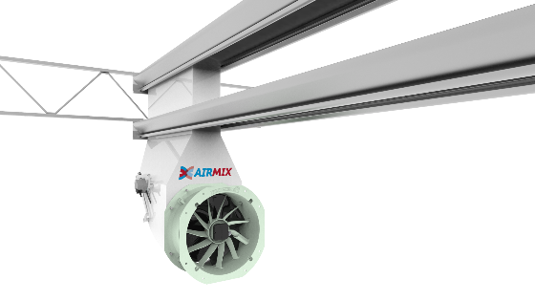

Appendix IV – Options and accessories

Condensation collection plate
This condensation collection plate is mounted underneath the Airmix in such a way that any condensation from the Airmix housing and the fan is collected. The surface of this plate has turned out to be large enough that the condensation evaporates again.

Speed controller (manual)
A simple control box with transformer and 6-position switch, with which the fans can be regulated in 5 different speeds and an off position. A three-phase transformer can be used that can supply
9.0 or 16.0 A.

Speed controller M-0-A (Manual – Off – Auto)
With this control box it is possible to control the fans by means of a 5-position switch. The control box is equipped with a manual 0-auto switch and a thermal protection. A three-phase transformer is used that can supply 9.0 or 16.0 A per phase.
Option: In automatic mode, a selection can be made between the 5 positions by means of a 24 Volt control voltage.

Outlet grille
Safety grille for mounting on the discharge side of the fan, the capacity of the fan is reduced by approx. 100 m³/h.

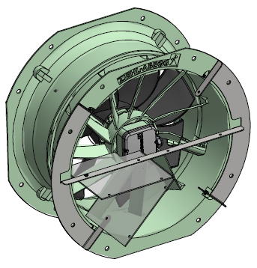
Air flow conductor
This air flow conductor is mounted on the discharge side of the fan. This allows the airflow to be limited upwards (against the flapping of the cloth) downwards (the airflow does not reach the crop too quickly).
By mounting 2 air flow conductor plates we create a so-called letterbox throw.

Mounting bracket for the air flow conductor
Four air flow conductor can be mounted per mounting bracket. When an outlet grille is chosen, the bracket is not necessary. The air flow conductor plates will then be mounted on the grille with tyraps.

Appendix V – Airmix valve position measuring device
To extract the required amount of air from above the screen, the valves must be controlled by the climate computer. There are several options: control on RH / AH or control on temperature in the greenhouse. The temperature above the screen must also be measured; if it rises too high, it will reduce the effect of the Airmix. The measurement above the screen will have to ensure a correct window position to discharge the moist and / or warm air to the outside.

In order to provide the climate computer with feedback on the actual position of the valves, a valve position detector must be installed on one Airmix per Airmix compartment. In practice, it is possible that a greenhouse is divided into several compartment. Each department then has its own climate control, so one Airmix in each compartment must be equipped with a valve position detector. The valve position detector must be mounted before the Airmix is suspended.

Appendix VI – Indicating obstacles

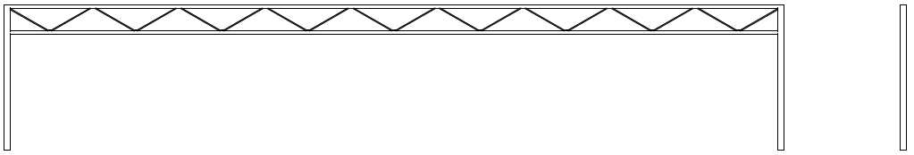
Please indicate where the Airmix cannot be mounted because of obstacles (spraying robot, lighting, etc.). Please indicate measurements.

